) Evaluate

(where a is a known constant. Note this is an indefinite integral)

) Evaluate 

(where f(y) is some given, known (well behaved) function of y)

) Evaluate 

4.) Make a quick sketch, in the *xy*-plane, of the following vector functions. Plot enough different vectors to get a feeling for what this field looks like in the *xy*-plane.

(a) 

(b) 

(c) 

Also just for this one (part c) - can you explain in words what this plot is showing?

5.) Given the scalar function T(x,y,z) (e.g. the temperature at any point in the room) which of the three operations (div, grad, or curl) can be sensibly operated on T?

For each which can:

a) Give a formula for the result.

b) Explain in words how you would interpret the result.

c) Is the result a vector or scalar?

6.) Given an arbitrary vector function **V**(x,y,z) (e.g. the velocity of a flowing liquid) which of the three operations (div, grad, or curl) can be sensibly operated on **V**?

For each which can:

a) Give a formula for the result.

b) Explain in words how you would interpret the result.

c) Is the result a vector or scalar?

7.) For each of the four vector fields sketched below....

Which of them have nonzero *divergence* somewhere? ______________

(If the divergence is nonzero *only* at isolated points, which point(s) would that be?)

Which of the following fields have nonzero *curl* somewhere? ___________________

(If the curl is nonzero *only* at isolated points, which point(s) would that be?)

*(A brief explanation of your answers below each figure would be welcome)*

**A. B**

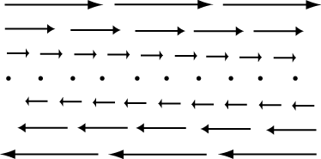 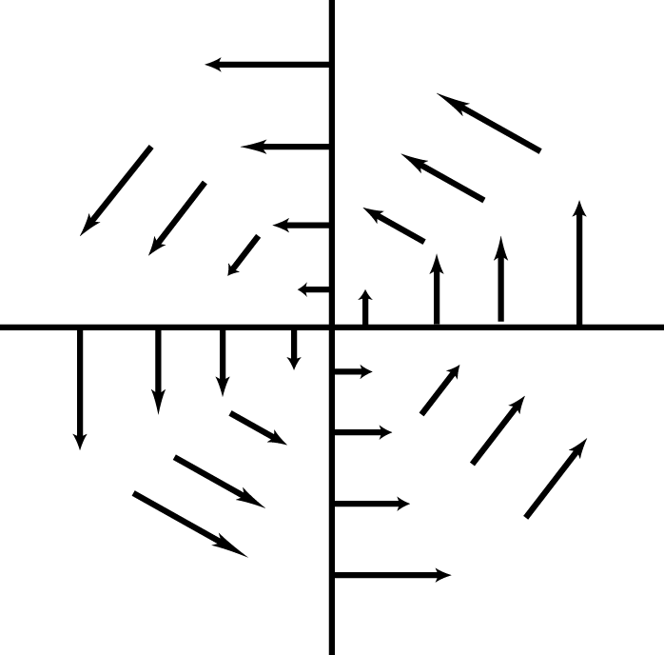

**C. D.**

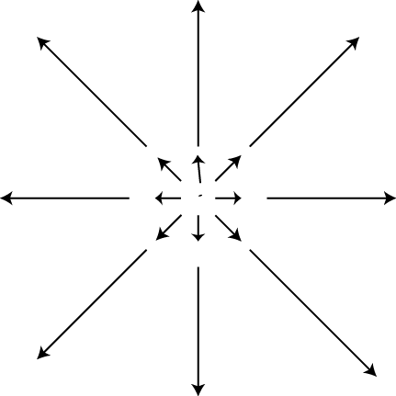 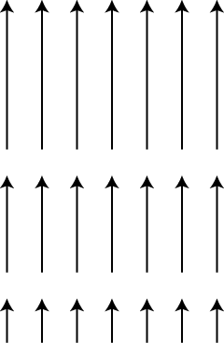

8.) Compute the gradient of the following scalar field: 

9.) Compute the divergence and curl of 

10.) Evaluate 

11.) Gauss' law says: , where **E** is the electric field, S is a closed surface, and  is a unit vector which points everywhere *outward* from the surface.

a) Explain briefly in words what this formula says, and how/when the formula might be used.

b) Suppose I evenly fill a cube (length L on a side) with electric charges. I then imagine a larger, closed cubical surface neatly surrounding this cube (length 2L on a side) Is Gauss' law TRUE in this situation? (Briefly, why or why not?)

Can one *use* Gauss' law (above) to simply compute the value of the electric field at arbitrary points outside the charged cube? (Don't try, just tell me if you *could,* and why/why not?)

c) Briefly but clearly, walk us through the derivation that takes you from Gauss' law as written at the top of the page to Gauss' law in "differential form".

d) What exactly is the electric field **E**? (Define it, and explain how to think about it, first mathematically *and* then in words? Please define any new technical words you introduce into your definition.)

12.) a) Given that an electric field in some region of space is given by ,

(where c is a given constant) what can you say about the charge density throughout this region, ρ(x,y,z)? Also, what are the units of c?

b) Given that the electric scalar potential in some region of space is given by V(x,y,z) = , what can you say about the charge density throughout this region, ρ(x,y,z)? Also, what are the units of c?